TITLE OF PAPER
(TIMES NEW ROMAN, 14 PT, BOLD, UPPERCASE)

NAME SURNAME ^{*1}, NAME SURNAME ² and NAME SURNAME³
(Times New Roman, Bold, 12pt)

¹ Affiliation :……. University, …….. Faculty, ……. Department, City, COUNTRY.
² Affiliation ………. University, …….. Faculty, ……. Department, City, COUNTRY.
³ Affiliation ……. University, …….. Faculty, ……. Department, City, COUNTRY.
(Times New Roman 12pt)

Page Layout and Style

This document represents a template for Book Chapter. It can be downloaded from the website, and used as a reference in the typesetting of the final paper. Extra information regarding the submission procedure is available at the website.
The page size is A4, which corresponds to a page of 210mm width and 297mm length (8.27'' x 11.69'').
The entire document must be in Times New Roman with size 12.
The text of the entire manuscript must be typed in 1.5 spacing.
Figures, tables and photographs should be set in the text. These should be consecutively numbered in bold type in the order of their appearance. All tables should be numbered with Arabic numerals. Every table should have a caption. Headings should be placed above tables. Only horizontal lines should be used within a table, to distinguish the column headings from the body of the table, and immediately above and below the table. Tables must be embedded into the text and not supplied separately. Below is an example which the authors may find useful.

Table 1. An example of a table.
Heading | Column A | Column B
 | 1 | 2
 | 3 | 4
 | 5 | 6

Every figure should have a caption. All photographs, schemas, graphs and diagrams are to be referred to as figures. Line drawings should be good quality scans or true electronic output. Figures must be embedded into the text and not supplied separately. Tables and Figures should be placed at the top or bottom of a page wherever possible, as close as possible to the first reference to them in the paper. Below is an example which the authors may find useful.
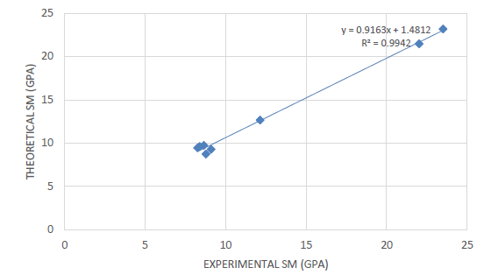

Figure 1. Test results

Use 1., 2., 3., ... for major, 1.1, 1.2, 1.3... for secondary, 1.1.1, 1.1.2, 1.1.3... headings.
Equation numbers should be Arabic numerals enclosed in parentheses on the right-hand margin. For example,

y = f (x) (1)

Citations should be made in the numbered [1].
Example:
Several studies [2-4] support this conclusion Book [5]. Chapter [6] Thesis [7]
Follow this order when typing manuscripts: Title, Authors, Affiliations, Main text Acknowledgements, References, Appendix.

References
References must be numbered in order of appearance in the text (including table captions and figure legends) and listed individually at the end of the manuscript. We recommend preparing the references with a bibliography software package, such as EndNote, Reference Manager or Zotero to avoid typing mistakes and duplicated references. We encourage citations to data, computer code and other citable research material. If available online you may use reference style below.

Citations and References in Supplementary files are permitted provided that they also appear in the main text and in the reference list.
In the text, reference numbers should be placed in square brackets [ ], and placed before the punctuation; for example [1], [1–3] or [1,3]. For embedded citations in the text with pagination, use both parentheses and brackets to indicate the reference number and page numbers; for example [5] (p. 10). or [6] (pp. 101–105).

- Surname, N, Title of manuscript or book, Name of journal/book. Year, Vol, (xx-xx).
- Stumm, W., and Melia, C.R.O. Stoichiometry of Coagulation. Jour. AWWA, 1968, 60(5):514-539.
- Black, A.P. Electrokinetic Characteristics of Hydrous Oxies of Aluminum and Iron. In Principles and Application of Water Chemistry. Edited by S.D. Faust and J.V. Hunter. New York: John Wiley and Sons. 1967.
- Johnson, P.N., and Amirtharajah A. Ferric Chloride and Alum as Single and Dual Coagulants. Jour. AWWA, 1983, 75(5):232-239

